Student Name:______________________________ Student Cell #:___________________ TOTAL $ Collected: ___________________
LINCOLN BAND FUNDRAISING
Forms & Money Due in Locked Box in Band Room by Monday, November 27, 2023
Instructions: Use this form to take orders for Culver’s Certificates and Stocking Caps. Donations to Feed the Band can be documented on the Form or made online. If made online, DO NOT write on the form! Add up totals for quantities and money. All money needs to be collected with the orders. If possible, write one total check to the Lincoln BPA (Band Parent Association) to turn in with order form. Students will be responsible for distributing certificates and stocking caps ordered. The Culver’s Certificates will be available after Nov 27 and the hats mid-December. More details to come!
If you have any questions, contact Lori Blom (contact information on the back)
Lincoln Band
Macy’s 2024
Special Edition Stocking Hat
$25
Unlimited # to sell!

Donate to Feed the Band online
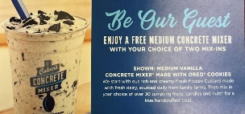

Concrete Mixer Certificates
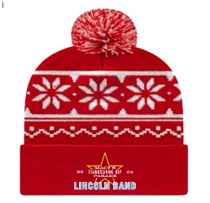

Unlimited # to sell! Cost $4/certificate
Culver’s Value Basket Certificates

Name | Cell # | # of Concrete Mixer Certs  (Cost $4) | # of Stocking Hats  (Cost $25) | Feed the Band donation | Total $
TOTAL:

Limit 10/student to sell

Value Basket Coupons

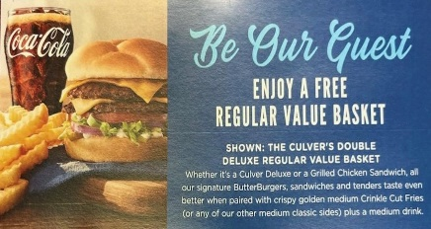

Cost: $10/certificate
Name | Cell # | # of Certs | $
TOTAL:

Lincoln Band Fundraisers
Forms & Money Due Monday, November 27, 2023

Here are three ways to raise funds starting now! The first will help all band members while the last two are specific ways to raise money for your ISA/Macy’s Trip cost. All three will begin now. Order Forms, along with money collected, will need to be turned in by Monday, November 27th into the locked box in the band room. Please collect the money and write one check for the entire amount to the Lincoln BPA. Band members will be responsible for picking up sold items and distributing once ready.

FEED THE BAND
Band Families, we need your help. In order to balance travel costs with school policy for rotational travel, the package does NOT include food costs. We also have other food costs throughout the next year’s season. In order to have enough funds for the students to eat, we are asking you to help us FEED THE BAND. How can you help?

- Identify 10 people/families that you can ask for a donation.
- Copy and paste the message below and send it out via email or text. We encourage you to add a personal touch! If you want to make it even more personal, call or you can even share when you meet your family and friends for Thanksgiving!
- Share on Social Media! Watch the Band pages for posts to share.
- Encourage people to talk to their employers to see if they do any matching gifts.

SAMPLE SCRIPT
“You may or may not know that (student name) gets a once in a life-time opportunity to march in the Macy’s Thanksgiving Parade in 2024! The Lincoln Band has a legacy of excellence, giving students a place to belong while building character. The parade will come after a season of competition which means extra expenses for next year. The band estimates that it will cost close to $100,000 next year alone to feed the band.

Would you be willing to help FEED THE BAND? Any amount is appreciated. Some ideas of what to give, here’s what your donation can do….

- $50 will provide snacks for a bus
- $350 will provide the meals for Macy’s for one band member
- $3,500 will feed the entire band a meal

You can donate online by using this link: https://www.zeffy.com/en-US/fundraising/1f3ae50d-52b2-4237-8e33-d565befb1777. All donations are tax deductible. Thanks for considering helping this great band that we love!

Culver’s
Band members can pre-sell:
- 10 Single Value Basket Certificates for $10/each. A savings of at least $2 to the buyer. Students will receive $3 to their ISA for each certificate sold.
- Unlimited Single Medium Concrete Mixers for $4/each. A savings of $1 to the buyer. Band members will receive $2 to their ISA for each certificate sold.
- Certificates will be all pre-sold starting November 13. Forms and all money collected is due in the band room lock box by November 27. Certificates will be available Nov 28 or 29 in the band room. Band members will be responsible for distributing bought certificates. Keep a copy of your order form!

Lincoln Band Macy’s Special Edition Stocking Hats
- Band members can pre-sell an unlimited amount of our limited edition Lincoln Macy’s Parade stocking hats! Hats will be sold for $ 25 and students will receive $ 10 for each stocking cap sold into their ISA. Stocking hats will be ready mid-December. Students will be responsible for distributing bought hats. Keep a copy of your order form.

QUESTIONS? Contact Lori Blom at lablom40@gmail.com or 605-261-8322

